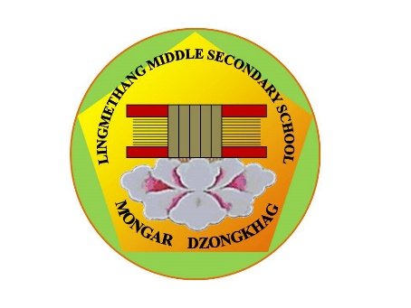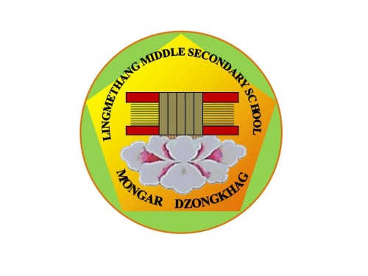

**དཔལ་ལྡན་འབྲུག་གཞུང་། ཤེས་རིག་ལྷན་ཁག།**

**Royal Government of Bhutan**

**Ministry of Education**

**LINGMETHANG MIDDLE SECONDARY SCHOOL, MONGAR**

Cultivating the grace of our mind

**LMSS/ADMI/TRANS/ 2021/ *41* Date: _____________**

*Paste recent photograph of the candidate*

**ADMISSION FORM FOR TRANSFER CASES**

1. **Details of students**
   1. Name:-___________________________________ 1.2. Sex: - _____________

1.3 Date of birth: - (DD/MM/YY) ____________________*(as certified by the head of the previous school)*

* 1. Citizenship Identity Card Number
  2. Mother’s tongue: - _________________________ 1.5 Nationality:- ____________________
  3. Admission sought for Class:- _____________ *(Class to be written in words)*
  4. Is the candidate repeater: YES NO

1.6 Name of the previous school in which the child was studying: - ______________________

* 1. Student’s Code No:-

*(The admission of the candidate shall not be accepted without the Student Code Number)*

1. **Details of Parents**
   1. Name of the Father/Mother:- _____________________________________________
   2. Citizenship ID No.: ______________________________________________________
   3. Occupation *(If Govt. service, state designation):-* _______________________________
   4. Village :- ____________________________ 2.5 Geog:- ____________________________

2.6 Dzongkhag: - ________________________ 2.7 House No.:-________________________

* 1. Tharm No.:- _________________________ 2.9 Contact Number :- __________________

1. **Reason for the change of School (Tick the appropriate one)**

Transfer of the parents

Health ground

Parent’s option

Others

1. **Documents required for the admission***.(Candidate shall not be accepted without the following documents)*
2. Transfer certificate and the mark sheet of the last class attended (original).
3. Citizen ID Card of both the parents (Photocopy)
4. Transfer order of the parents and letter from the Head of the organization/institute, if employee
5. Students’ Health Handbook
6. A recent passport size photograph of the child

**………………………………………………………………………………………………………………………....**

*I hereby declare that the above information is true and correct. I fully hold the responsibility of any misinformation if noted.*

**Name and Signature of Parent**

**……………………………………………………………………………………………………………….**

**For Office Use Only**

The admission sought is

Approved for Class *(Class to be written in words)*

Not Approved

If approved, School Admission Number

**……………………………………………………………………………………………………………….**

**Signature of the Admission Committee**

**CHAIRMAN**

**School Admission Committee**

**PRINCIPAL**

**Lingmethang Middle Secondary School**

**Mongar Dzongkhag**

Tele (Office) +975 04 744223 || Principal 17695246||Email [mg.lingmethangmss@education.gov.bt](mailto:mg.lingmethangmss@education.gov.bt)

 *‘Together Everyone Achieves More’*