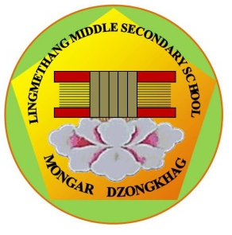

དཔལ་ལྡན་འབྲུག་གཞུང་། ཤེས་རིག་ལྷན་ཁག།
Royal Government of Bhutan
Ministry of Education
LINGMETHANG MIDDLE SECONDARY SCHOOL, MONGAR
Cultivating the grace of our mind

Casual Leave Application Form

Application addressed to: The Principal, Lingmethang Middle Secondary School

1. Name of the applicant:

2. Nature of leave applied:

3. Period of leave (From – To):

4. Ground of leave applied for:

5. Address during the leave:

Date: Signature of the applicant

-------------------------------------------------------------------------------------------------------------------

For office use only

The leave applied by _________________________________________ is approved/not approved.
The leave is approved for _________________day (s)

Signature of the Principal
PRINCIPAL
Lingmethang Middle Secondary School
Mongar Dzongkhag

Tele (Office) +975 04 744223 || Principal 17695246||Email mg.lingmethangmss@education.gov.bt
 ‘Together Everyone Achieves More’

