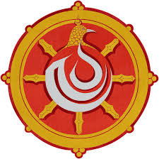
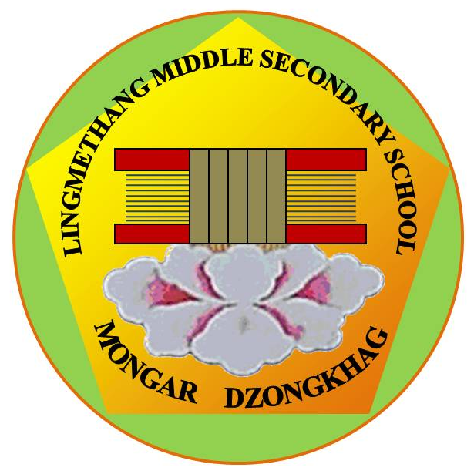

དཔལ་ལྡན་འབྲུག་གཞུང་། ཤེས་རིག་ལྷན་ཁག།
Royal Government of Bhutan
Ministry of Education
LINGMETHANG MIDDLE SECONDARY SCHOOL, MONGAR
Cultivating the grace of our mind

Co-curricular Activities Report Form

1. Name of the Event/Activity: _________________________________________________

2. Date/Period of the event conducted: __________________________________________

3. Aim: ______________________________________________________________________

_____________________________________________________________________________

4. Objectives: At the end of the event/activity, it is expected to;

_____________________________________________________________________________

_____________________________________________________________________________

5. State the following in brief

3 things that went on well | 3
3 things that went on well | 2
3 things that went on well | 1
2 things that did not go well | 2
2 things that did not go well | 1
1thing that we need to improve upon. | 1

Name and signature of Event Coordinator Principal

Tele (Office) +975 04 744223 || Principal 17695246||Email mg.lingmethangmss@education.gov.bt
 ‘Together Everyone Achieves More’

