
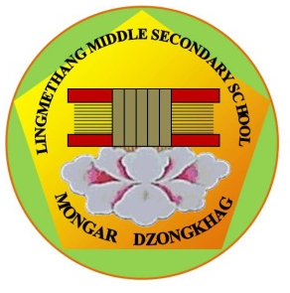
དཔལ་ལྡན་འབྲུག་གཞུང་། ཤེས་རིག་ལྷན་ཁག།
Royal Government of Bhutan
Ministry of Education
LINGMETHANG MIDDLE SECONDARY SCHOOL, MONGAR
Cultivating the grace of our mind

PD Report Form

- Name of the PD:

- Date of the PD conducted:

- Aim:

- Objectives: At the end of the professional development programme, it is expected to:

- Action Steps (What are the things that have to be done to fulfill the objectives?)

  - Before :

  - During:

  - After :

- Process(How would you carry out your activities)

- Total cost of the PD Programme

- Follow up of the PD Programme( How would you monitor the learning outcomes of the teachers from the PD Programmes)

Name and Signature of the PD Coordinator PRINCIPAL
Lingmethang Middle Secondary School
Mongar Dzongkhag

