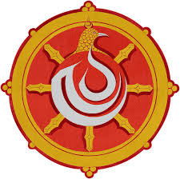
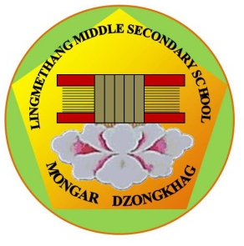
དཔལ་ལྡན་འབྲུག་གཞུང་། ཤེས་རིག་ལྷན་ཁག།
Royal Government of Bhutan
Ministry of Education
LINGMETHANG MIDDLE SECONDARY SCHOOL, MONGAR
Cultivating the grace of our mind

INVENTORY AND MONITORING OF TEACHING LEARNING MATERIALS

- Teaching Materials

TLM Type | Quantity in use | Quality | Frequency of use [per week] | Remarks
Maps/Globes
Wall Charts
Flip Charts
Flash Cards
Kits
Scientific Models
Any other, please mention

- Supplementary Learning Materials

SLM Type | Quantity in use | Quality | Frequency of use [per week] | Remarks
Books
Newspaper
Magazines
Charts
Kits
Sports equipment
Music instruments
Visual art instruments
Audio tapes, CD, DVD
Video tapes, CD, DVD
Access to computers
Access to internet
Projector
Any other, please mention

Name of the teacher: __________________________________

Classes/subject taught: _________________________________

Assessed by Verified by Endorsed by
Head of Department Academic Head Principal

