
དཔལ་ལྡན་འབྲུག་གཞུང་། ཤེས་རིག་ལྷན་ཁག།
Royal Government of Bhutan
Ministry of Education
LINGMETHANG MIDDLE SECONDARY SCHOOL, MONGAR
Cultivating the grace of our mind

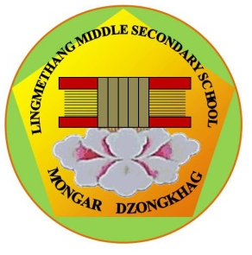
TOD Monitoring Report Form

Name of Teacher: …………………………………………….

Period of ToD: (From …………………………….. to .……………..………………)
CLEANING AREA OF DIFFERENT HOUSES
Area One: Tshenden House
Old Staff toilet, Citrus garden, Upper Academic block, and steps leading to staff quarter
Area Two: Bjaro House
Assembly ground, Middle Academic blocks, Approach road leading to main gate and toilet footpath.
Area Three: Dronggyemtse House
ADM block and surroundings including steeps and parking area
Area Four: Tsherngoen House
Lower academic block, IT Lab and footpath leading to lower teacher’s residence

State the following in brief. This monitoring form should be submitted to the office on Monday after teacher completes the tenure as ToD.

- Area supervised in a week: (Tick the area below)
Area 1
Area 2
Area 3
Area 4
- Most cleaned area of the week(Support your finding(s) by listing some evidences)

- Any important Celebrations/Observations in the week (Describe the event)
………………………………………………………………………………………………………………………………………………………………………………………………………………………………………………………………………………………………………………………………………………………………

- Important Announcement/ Reminder
………………………………………………………………………………………………………………………………………………………………………………………………………………………………………………………………………………………………………………………………………………………………

- Visitors (Name the visitor and write the purpose of visit, If any)
…………………………………………………………………………………………………………………………………………………………………………………………………………………………………………

- Co-curricular activities (Impact in the students learning)
…………………………………………………………………………………………………………………………………………………………………………………………………………………………………………
……………………………………………………………………………………………………………………

- Overall Comment(s)and findings
………………………………………………………………………………………………………………………………………………………………………………………………………………………………………...
[Signature of Teacher on Duty] [PRINCIPAL]

