དཔལ་ལྡན་འབྲུག་གཞུང་། ཤེས་རིག་ལྷན་ཁག།
Royal Government of Bhutan
Ministry of Education
LINGMETHANG MIDDLE SECONDARY SCHOOL, MONGAR
Cultivating the grace of our mind

Undertaking form for Guardian incase the child is a dependent

I Mr. /Ms __________________________legal guardian of Master/ Miss __________________ student of class ______________do hereby undertake and confirm the following;
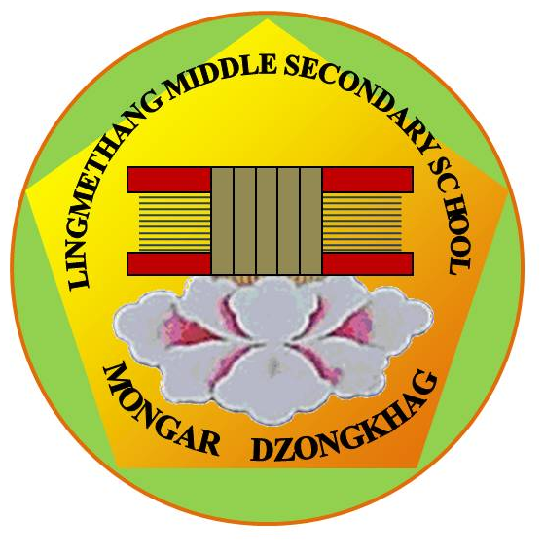
He / she is my ___________________ (specify relationship) and I am his/her guardian.

Provide food, clothing, shelter and education to the child.

Protect, discipline and educate the child.

Provide necessary health care to the child.

Look after the social and school activities of the child.

Make sure to follow school discipline and code of conduct.

Punctuality and regularity in attendance will be maintained.

Any communication or notice sent to the guardian will be acknowledged.

Accept all terms and conditions of the school and undertake to fully abide by it.

The above undertaking is voluntary and with free will/consent, I hereby signed thereof,

Date :
Place :
Name and Signature of Guardian:

